Project 5

Scheduling a basic job in jenkins

ss:jenkins home page with job list

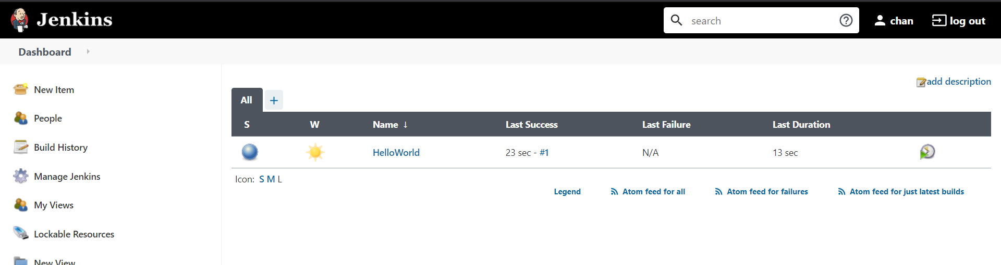

Task2: Configure git SCM

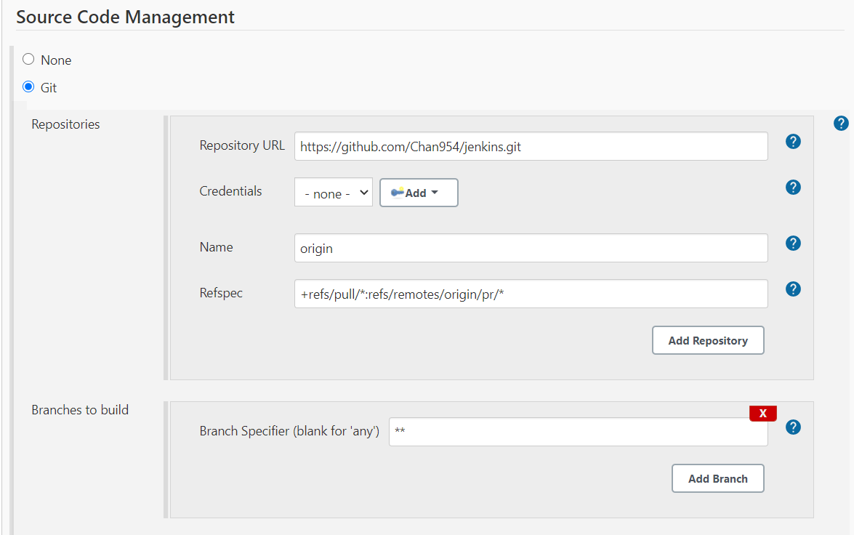

Add build step-java commands in execute windows batch commands

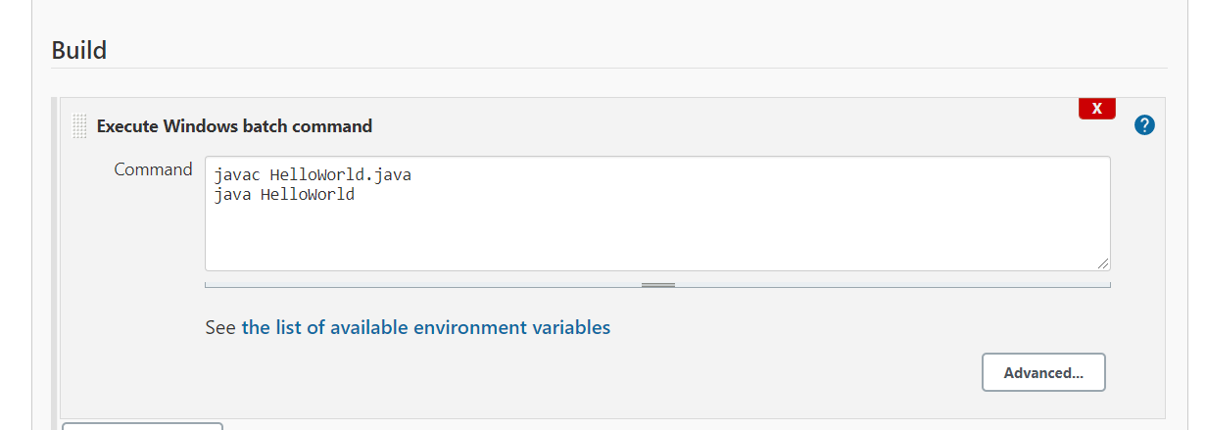

: Run a build and show console output

